|  |  |
| --- | --- |
| **Status** | Finished |
| **Started** | Tuesday, 12 November 2024, 5:33 PM |
| **Completed** | Tuesday, 12 November 2024, 11:06 AM |
| **Duration** | 32 days 6 hours |

Top of Form

Question **1**

Correct

Marked out of 3.00

Flag question

Question text

Alice and Bob are playing a game called "Stone Game". Stone game is a two-player game. Let N be the total number of stones. In each turn, a player can remove either one stone or four stones. The player who picks the last stone, wins. They follow the "Ladies First" norm. Hence Alice is always the one to make the first move. Your task is to find out whether Alice can win, if both play the game optimally.

Input Format

First line starts with T, which is the number of test cases. Each test case will contain N number of stones.

Output Format

Print "Yes" in the case Alice wins, else print "No".

Constraints

1<=T<=1000

1<=N<=10000

Sample Input and Output

Input

3

1

6

7

Output

Yes

Yes

No

Answer:(penalty regime: 0 %)

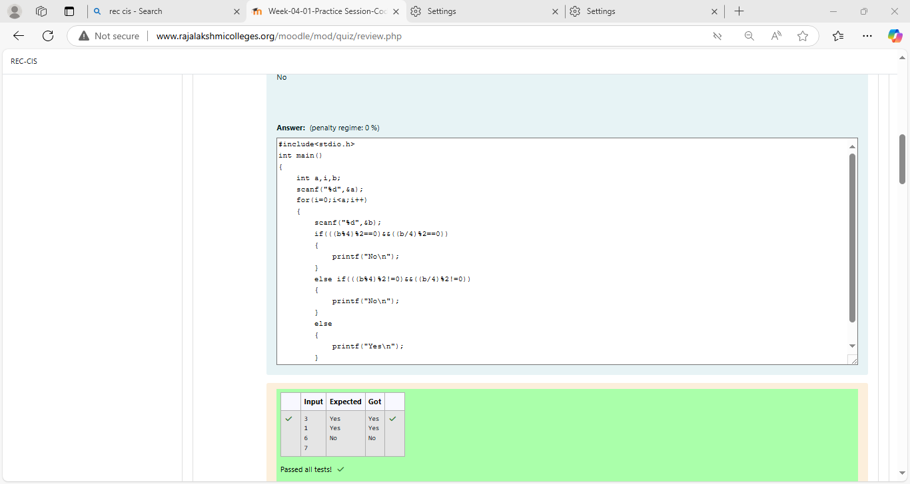

Feedback

|  | **Input** | **Expected** | **Got** |  |
| --- | --- | --- | --- | --- |
|  | 3  1  6  7 | Yes  Yes  No | Yes  Yes  No |  |

Passed all tests!

Question **2**

Correct

Marked out of 5.00

Flag question

Question text

You are designing a poster which prints out numbers with a unique style applied to each of them.  The styling is based on the number of closed paths or holes present in a given number.

The number of holes that each of the digits from 0 to 9 have are equal to the number of closed paths in the digit. Their values are:

1, 2, 3, 5, and 7 = 0 holes.

0, 4, 6, and 9 = 1 hole.

8 = 2 holes.

Given a number, you must determine the sum of the number of holes for all of its digits. For example, the number 819 has 3 holes.

Complete the program, it must must return an integer denoting the total number of holes in num.

Constraints

1 ≤ num ≤ 109

Input Format For Custom Testing

There is one line of text containing a single integer num, the value to process.

Sample Input

630

Sample Output

2

Explanation

Add the holes count for each digit, 6, 3 and 0. Return 1 + 0 + 1 = 2.

Sample Case 1

Sample Input

1288

Sample Output

4

Explanation

Add the holes count for each digit, 1, 2, 8, 8. Return 0 + 0 + 2 + 2 = 4.

Answer:(penalty regime: 0 %)

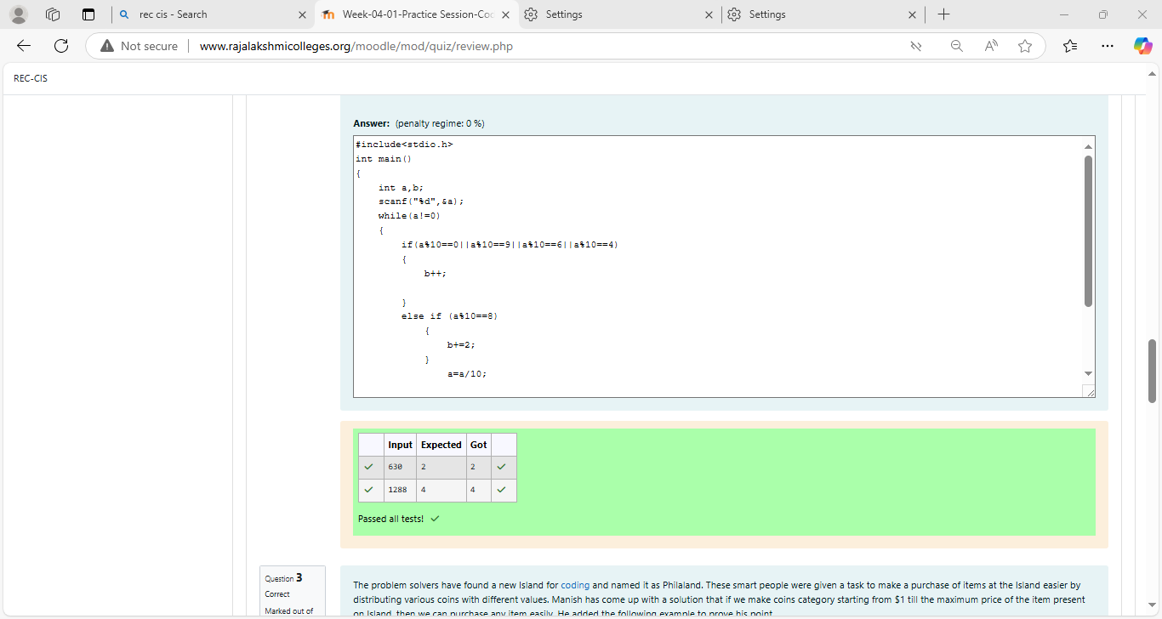

Feedback

Passed all tests!

Question **3**

Correct

Marked out of 7.00

Flag question

Question text

The problem solvers have found a new Island for [coding](http://www.rajalakshmicolleges.org/moodle/mod/quiz/view.php?id=181) and named it as Philaland. These smart people were given a task to make a purchase of items at the Island easier by distributing various coins with different values. Manish has come up with a solution that if we make coins category starting from $1 till the maximum price of the item present on Island, then we can purchase any item easily. He added the following example to prove his point.

Let’s suppose the maximum price of an item is 5$ then we can make coins of {$1, $2, $3, $4, $5}to purchase any item ranging from $1 till $5.

Now Manisha, being a keen observer suggested that we could actually minimize the number of coins required and gave following distribution {$1, $2, $3}. According to him any item can be purchased one time ranging from $1 to $5. Everyone was impressed with both of them. Your task is to help Manisha come up with a minimum number of denominations for any arbitrary max price in Philaland.

**Input Format**

Contains an integer N denoting the maximum price of the item present on Philaland.

**Output Format**

Print a single line denoting the minimum number of denominations of coins required.

**Constraints**

1<=T<=100

1<=N<=5000

**Refer the sample output for formatting**

**Sample Input 1:**

10

**Sample Output 1:**

4

**Sample Input 2:**

5

**Sample Output 2:**

3

**Explanation:**

For test case 1, N=10.

According to Manish {$1, $2, $3,… $10} must be distributed.

But as per Manisha only {$1, $2, $3, $4} coins are enough to purchase any item ranging from $1 to $10. Hence minimum is 4. Likewise denominations could also be {$1, $2, $3, $5}. Hence answer is still 4.

For test case 2, N=5.

According to Manish {$1, $2, $3, $4, $5} must be distributed.

But as per Manisha only {$1, $2, $3} coins are enough to purchase any item ranging from $1 to $5. Hence minimum is 3. Likewise, denominations could also be {$1, $2, $4}. Hence answer is still 3.

Answer:(penalty regime: 0 %)

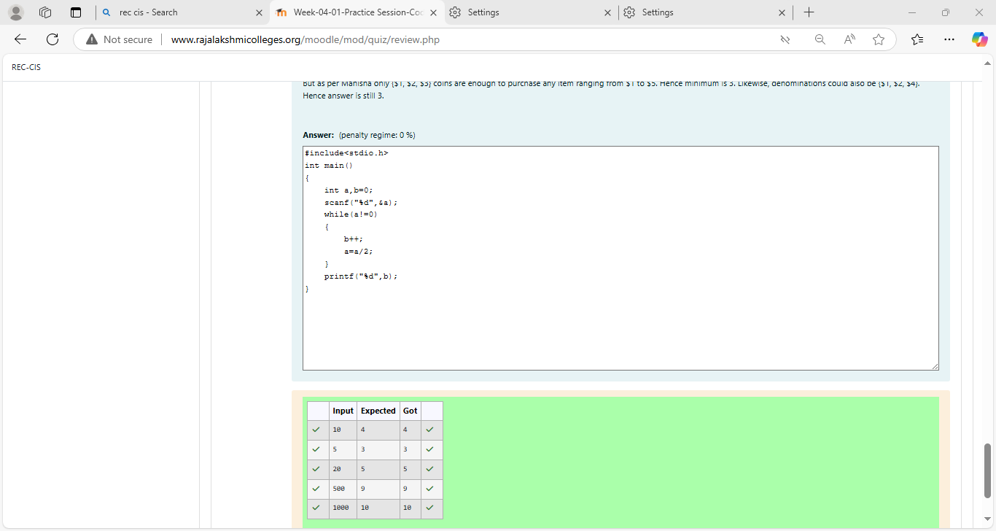

Feedback

Bottom of Form